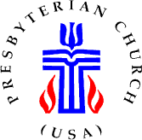

2024 Stated Meeting of the
Presbytery of Redstone Presbyterian Church (USA)

November 23, 2024



Community United Presbyterian Church,
New Alexandria
and
ZOOM VIDEO CONFERENCING MEETING

Communicate the Word…Carry on the Work…Change the World
Together

Directions to
Community United Presbyterian Church
1640 Keystone Park Rd., New Alexandria, PA 15670
724.668-7752

Directions from Greensburg: Head northeast on S. Urania Ave. toward E. Pittsburgh St. Turn Left onto E. Pittsburgh St. E. Pittsburgh St. turns slightly right and becomes E. Oterman St. Turn right onto Arch Ave. Turn Right onto Beacon St. Continue onto US-119 N/New Alexandria Rd for 8.7 miles. Turn right onto US-119/US-22E. Turn Right onto PA-981 S. Turn left onto Pleasant Vue Dr. Turn right onto Kier St. Turn Left on to Keystone Park Rd. The church will be on your left.

Directions from Blairsville: Take US-119/US-22W. Turn left onto PA-981 s. Turn left onto Pleasant Vue Dr. Turn right onto Kier St. Turn left onto Keystone Park Rd. The church will be on your left

Directions from Latrobe: Take PA-981 N. Turn Right onto Pleasant Vue Dr. Turn right onto Kier St. Turn left onto Keystone Park Rd. The church will be on your left.

GENERAL INSTRUCTIONS FOR THE MEETING

- The offering for this meeting will go to the South Sudan Presbyterian Evangelical Church Partnership.
To make your Offering through online contributions go to www.redstonepresbytery.org and click on the green “GIVE NOW” link on the left of the page.
You will need to login – or create a profile if you don’t already have one – and then designate your offering in the space(s) provided. You may also mail your Offering to the Presbytery office at 1004 Mt. Pleasant Road, Greensburg, PA 15601. Please designate “Presbytery Offering” on the memo line.

- Presbyters are reminded to get “Prayer Requests” to the Clerk as soon as possible as they will be lifted up during the prayers in the Worship Service.
- New Business must be submitted to the Associate Stated Clerk in writing before the end of worship.

Community Presbyterian Church, New Alexandria
In Person or Zoom meeting
November 23, 2024

8:30-  9:00 a.m. | - Registration and fellowship | In Person/Online
 | GATHERING
9:00 a.m. | Presbytery Gathering Convenes  Announcements Loop  Opening Prayer  - Formation of the Roll  - Establishment of Quorum  - Seating of Corresponding Members  - Introduction of Elders  On the Road with Redstone | Sanctuary/Zoom  Len Morgan  Rev. Cliff Foster  Rev. Don Glunt
 | Reports  Stated Clerk  - Consent Agenda (pages 5-6)  Treasurer (page 7)  Synod Commissioners  Executive Presbyter (page 8-10) | Rev. Skip Noftzger  Rev. Cliff Foster  John Dickson  Bernice Adams  Susan Nesti  Rev. Cliff Foster  Rev. Skip Noftzger
 | SHARING IN WORSHIP – page 11
Gathering
-Hymn - “The Church of Christ Cannot Be Bound”

 | Ministry of the Word  -Sermon  -Hymn - “ Glory to God, Whose Goodness Shines on Me” | Len Morgan
Response
-Affirmation of Faith
-Offering
- Doxology –

Sacrament - Lord’s Supper
-Hymn – “Though I May Speak”
Sending
-Hymn – “We Are One In the Spirit”
 | SHARING IN MINISTRY AND MISSION
 | Equipping Leadership  Nominating Committee (page 19)  - Vice Moderator nomination  - Standing Committees  Committee on Preparation for Ministry (page 20)  - IPLF program  Enabling Ministry Networks  Council—page 21  - 2025 Budget (second reading) Appendix D  - G-3.0302d-removing the requirement of a concurrence on overtures submitted by presbyteries  - Communications Network  - Interim Executive Presbyter Search Committee  Empowering Mission Partnerships  - Pine Springs Camp – page 25  - Mission Subcommittee – page 26  ----Congregation mission  Engaging Congregations  Committee on Ministry— page 27  - Commissioning Jackie Eckenrod  - Retirement of Mary Kay Glunt  - Retirement of Skip Noftzger | Glenn Hart  Robin Jennings  Rev. Dawn Sherwood  Rev. Sue Washburn  Rev. Norma Murphy  Greg Davis  Rev. Owar Ojulyu  Rev. Donna Havrisko
 | Announcements Loop
 | Soli Deo Gloria  Resolution of Thanks  Benediction  Adjournment  The next stated meeting of the Presbytery of Redstone will take place on January 25 2025, 1:00 p.m. by Zoom or at the First Presbyterian Church, Greensburg, PA. | Rev. Skip Noftzger  Len Morgan

By God’s grace,
Communicate the Word,
Carry on the Work,
Change the World!

STATED CLERK’S REPORT:
- During the period since the last regularly stated Presbytery meeting, all correspondence that was received was responded to and/or appropriately routed for review and response to the appropriate entity of Presbytery.

Stated Clerk Correspondence Log

Date Received | Received From | Content | Action
November 13, 2024 - Mail | Marion Presbyterian Church | 2025 Terms of Call and new contract for Robert C. Prinkey | To Com & File
November 11 2024 - email | Rev. Jihun Oh, Executive Director & Stated Clerk of the General Assembly | Changes for the Interim Unified Agency (IUA) formerly the Presbyterian Mission Agency | File
November 7, 2024 - mail | Bethel United Presbyterian Church | 2025 Terms of Call for James Sunseri | To Com and File
November 5, 2024 – in-person | Rev. Patrik Ewing | Personal Discernment Profile | To COM and File
November 4, 2024 - mail | Derry PC | Covenant Pastor Agreement for Larry Armstrong | To COM and File
November 4, 2024 - email | Delmont PC | Interim Pastor’s Contract 11/2024 – Anthony Catullo | To COM and File
October 28, 2024 - email | West Newton, Sewickley | 2025 Terms of Call for Karen Kifer | To COM and File
October 23, 2024 mail | PILP | 3rd Quarter Report | File
October 21, 2024 email | Rev. Antrew Wirt, West Hempfield, Irwin | Approval & Invitation to Host the September 3, 2025 Presbytery Meeting | To Council and File
October 9, 2024 email | Rev. Brian Kilbert, Puckety, Lower Burrell | Approval & Invitation to Host the May 27, 2025 Presbytery Meeting | To Council and File
October 8, 2024 email | West Newton, United | Minutes from October 6, 2024 to dissolve relationship with John Manon | To Com and File
October 8, 2024 - email | Bethel UP | 2025 Commitment Form | File
October 7, 2024 - mail | PC(USA) Office of Special Offerings | Christmas Joy Offering | To Mission and File
  - The list of proposed presbytery meeting dates for the 2025 calendar year approved by the Council are presented below. We welcome invitations to serve as meeting host for any of these meetings.
    - January 25—First Presbyterian, Greensburg (Hybrid-In person/Zoom)
    - March 25— McClellandtown Presbyterian (Hybrid-In person/Zoom)
    - May 27— Puckety Presbyterian, Lower Burrell (Hybrid-In person/Zoom)
    - September 23—West Hempfield Presbyterian, Irwin (Hybrid-In person/Zoom)
    - November 22—Newlonsburg Presbyterian, Murrysville (Hybrid-In person/Zoom)

  - Review of the 2023 Session minutes and Church Registers has been completed and submitted to the COM (Appendix A). The minutes and the church registers of the following congregations were not reviewed: Adah, Palmer; Bolivar; Hopewell; Dunbar; Ligonier; Merritstown; Calvin, Scottdale; Tent; Sewickley

CONSENT AGENDA:
The Associate Stated Clerk of the Presbytery, Rev. Cliff Foster, presents the following Consent Agenda:

From Executive Committee
- Following the review of the Moderator, Vice-Moderator, Stated Clerk and Associate Stated Clerk, it is recommended that the minutes of the Presbytery meeting of the September 24, 2024, be approved.

From the Council
- Council recommends that the Financial Reports presented to the Council and the Presbytery be received and filed for audit. (Appendix ‘C’)

- Council recommends that the Executive Presbyter, Treasurer, Mission, and Pine Springs Camp reports presented to the Presbytery be received and filed.

- Council recommends that the written reports of all committees, networks and task forces be received and filed.

- Council recommends approval of the BOO amendment of the fourth paragraph of G-3.0106 be amended as follows to include: “adults with vulnerabilities” to the protection policy (Full text of amendment in Appendix ‘A’)

- Council recommends approval of the BOO amendment of G-3.0501 Composition and Responsibilities be amended reducing the size of presbytery membership relative to the number of commissioners. (Full text of amendment in Appendix ‘A’)

- Council recommends approval of the Episcopal-Presbyterian Agreement on Local Sharing of Ministries (24-M). (Full text of amendment in Appendix ‘B’)

From the Committee on Ministry

From the Committee on Preparation for Ministry
From the Nominating Committee
From the Committee on Representation

Treasurers Report
Redstone Presbytery Council Meeting
Tuesday, October 22, 2024

INCOME & EXPENSE REPORT

This report provides an unaudited overview of the September 2024 financials for the Redstone Presbytery. At this time, it is anticipated Church Commitments receipted from pledges are at the 75% benchmark level. September represents the ninth (9) budget period for the Presbytery.

FINANCIAL OVERVIEW /INCOME

Income within the Contribution Income Unrestricted category (Church Commitments and other resources) totaled $19,815, versus a monthly goal of $26,667. This category of income is primarily supported from Church Commitments. For the month, this source of revenue reflects a deficit of -$6,852. Total monthly funds for the year are noted at $208,567, versus a benchmark goal of $240,003 for the end of September. Therefor YTD, there is a negative -$31,436 in cash flow.

Subtotal Total Income for the month, which includes ministry contributions is $29,515, versus a goal of $30,833 or a -$1,318 shortfall. YTD, $244,755 has been receipted versus a benchmark of $277,500, representing a -$32,745 shortfall.

Total Income recognized for the current month was $30,664, versus a goal of $31,833. YTD, $286,363 has been collected versus a goal of $286,497. The small YTD negative variance of -$134.00 is supported by the Miscellaneous Income of $37,784, which represents the sale of The Fayette City Church.

CHURCH COMMITMENT ACTIVITY

For this time period, of the sixty-seven (67) churches within the Redstone Presbytery, the following activities in regards to the number of pledges, payments provided, payment percentages of goals, are noted as follows:
- 39 Pledges have been offered of the 67 churches (58% participation)
- 27 Churches have not offered a pledge
- 55 Churches have provided a payment during 2024
- 19 Churches have met or surpassed the 75% pledged budgeted benchmark for this time period

FINANCIAL OVERVIEW / EXPENSES

Expenses recorded for the month totaled $27,048, which is below the budgeted benchmark of $36,881 (+$9,833 variance). YTD, total expenses recorded are $310,850 versus a benchmark of $331,925 (+$21,075 variance). There were a few expense categories that peak above the 75% benchmark for the year at this time, such expenses are related to timing and need matters.

INVESTMENTS & HOLDINGS

Ameriprise investments for the end of September had an ending value totaling $780,464 ($14,741 positive increase from August & $14,956 positive increase from July, or $29,697 in the past two months).

Other holdings and investments consisting of First Commonwealth
($36,975), PILP ($10,000), Petty Cash ($250.00), and New Covenant
($358,844) total $406,069.

Total Investments & Holdings = $1,186,533

MINISTRY AND MISSION REPORTS

Executive Presbyter

Rev. Richard “Skip” Noftzger
Executive Presbyter Report

Communicate the Word, Carry on the Work, Change the World…Together!
VISION | 9/24/2024-11/23/24
Congregation-centered  (ENGAGE) | Visible presence within the Presbytery engaging with congregations  Church Visits –  - Visited churches in person for worship services or special events ten times in various congregations. Preached five times in service of some of those congregations.  - Moderated, resourced and consulted with two different sessions. Advised other church sessions on concerns related to pastoral needs, and future ministry options.  - Consulted with the active PNC’s and Sessions in the process of developing the ministry information, discerning, and making call decisions. At least weekly, scanning CLC and making additional referrals. Checking in regularly with them on progress.  - Served as resource person to Committee on Ministry teams engaged with various congregations.  - Identified possible options for preaching and other pastoral concerns for congregations without continuing pastoral leadership.
Leadership developed  (EQUIP) | Developing and equipping leadership within the Presbytery –  - Consulted and coached on an individual level at least three pastors within the presbytery regarding educational needs, personal development, as well as concerns of conflict mediation, pastoral care, and executive leadership.  - Worked alongside and resourced various standing committees and subcommittees of the Presbytery anticipating the transition after my retirement. This included establishing annual calendars for 2025 of both responsibilities and meeting dates.  - Directed, initiated, scheduled, and promoted Inter-Presbytery Leadership Formation courses and workshops available to and participated in by six presbyteries of southwestern PA and panhandle of West Virginia.  - Individual follow up for mentoring and training of candidates and ruling elders preparing for possible commissioned service.  - Provided pastoral care for pastors encountering personal and family difficulties and uncertainties in vocation.  - Individual meeting and preparation for the transition of Stated Clerk responsibilities including set up and transfer of online access. Provided training in the use of the Stated Clerk portal that involves administrative tasks related to Eminister, Statistics, Prep4Min, CLC, Church change forms, Mid-Council forms and Amendment voting.
Collaboration- Districts/Network  (ENABLE) | Joined and initiated contact both within and outside Redstone-  - Active participant in the planning committee for the World Mission Initiative conference planned and implemented in 2024.  - Coordinated the work with the steering committee of Wee Kirk in order to begin planning and marketing of the conference and retreat in 2025.  - Ongoing engagement with the other presbytery executives in sharing resources, perspectives, and availability of church leadership.  - Participated in the annual assembly of the Synod of the Trinity along with leading a devotional on one morning.  - Ongoing ecumenical engagement with nearby colleagues in the overlap with Redstone and as partner in Christian Associates with the whole of western Pennsylvania.
Partnership in Mission Promoted  (EMPOWER) | Promoted and provided leadership in our partnerships in mission –  - Supported our Sudan/S. Sudan Partnership Network through participation, communication, and administrative leadership. Convened the gathering of the annual partnership network gathering at Antiochian Village.  - Worked with the Mission committee on the ongoing completion of the mission quilt project.  - Coordinated a visit from Robert Gamble from This Child Here; a mission group operating in the Ukraine with mothers and children in internal displaced camps.  - Participated in the strategic planning retreat with the PSC Board. Consulted with the Pine Springs Camp Executive Director on the next steps going forward. Participated in the PSC annual “Friends” dinner by making the “ask” for support.  Continued service and participation as an ex-officio member of the board of Redstone Highlands.
Operational Support | - Oversight of the minutes and registration book reviews. Personally reviewed a number of records. Following up with others who have assumed individual responsibility.  Directed necessary maintenance and repairs within the Presbytery center facility.  Developed additional protocols both for the transition period and long term regrading accounts receivable and accounts payable.  Working with task forces on the review of Book of Order amendments approved at the most recent General Assembly. Plans developed included referrals to standing committees and proposed timelines for consideration within the Presbytery.  Consulted with auditors on the completion of the financial review of the Presbytery. Shared draft with the Finance Committee for transparency and prepared Council for receiving the report and review.
VALUES | Servant Leadership | Flourishing Community | Witness to the World | Generous and effective Stewardship
 | Soli Deo Gloria

Presbytery Worship:
A Community of Love

Prelude

Gathering

The Church is the body of Christ. Book of Order, F-1.03
Christ gives to the Church
all the gifts necessary to be his body.

The Church strives to demonstrate these gifts
in its life as a community in the world.
The Church is to be a community of love,

where sin is forgiven, reconciliation is accomplished,
and the dividing walls of hostility are torn down.
Where Christ is, there is the true Church.

We affirm that, in the power of the Spirit,
the Church is faithful to the mission of Christ
as it proclaims and hears the Word of God,
administers and receives the Sacraments,
and nurtures a covenant community of disciples of Christ.

Prayer of the Day

*Hymn #766 “The Church of Christ Cannot Be Bound”

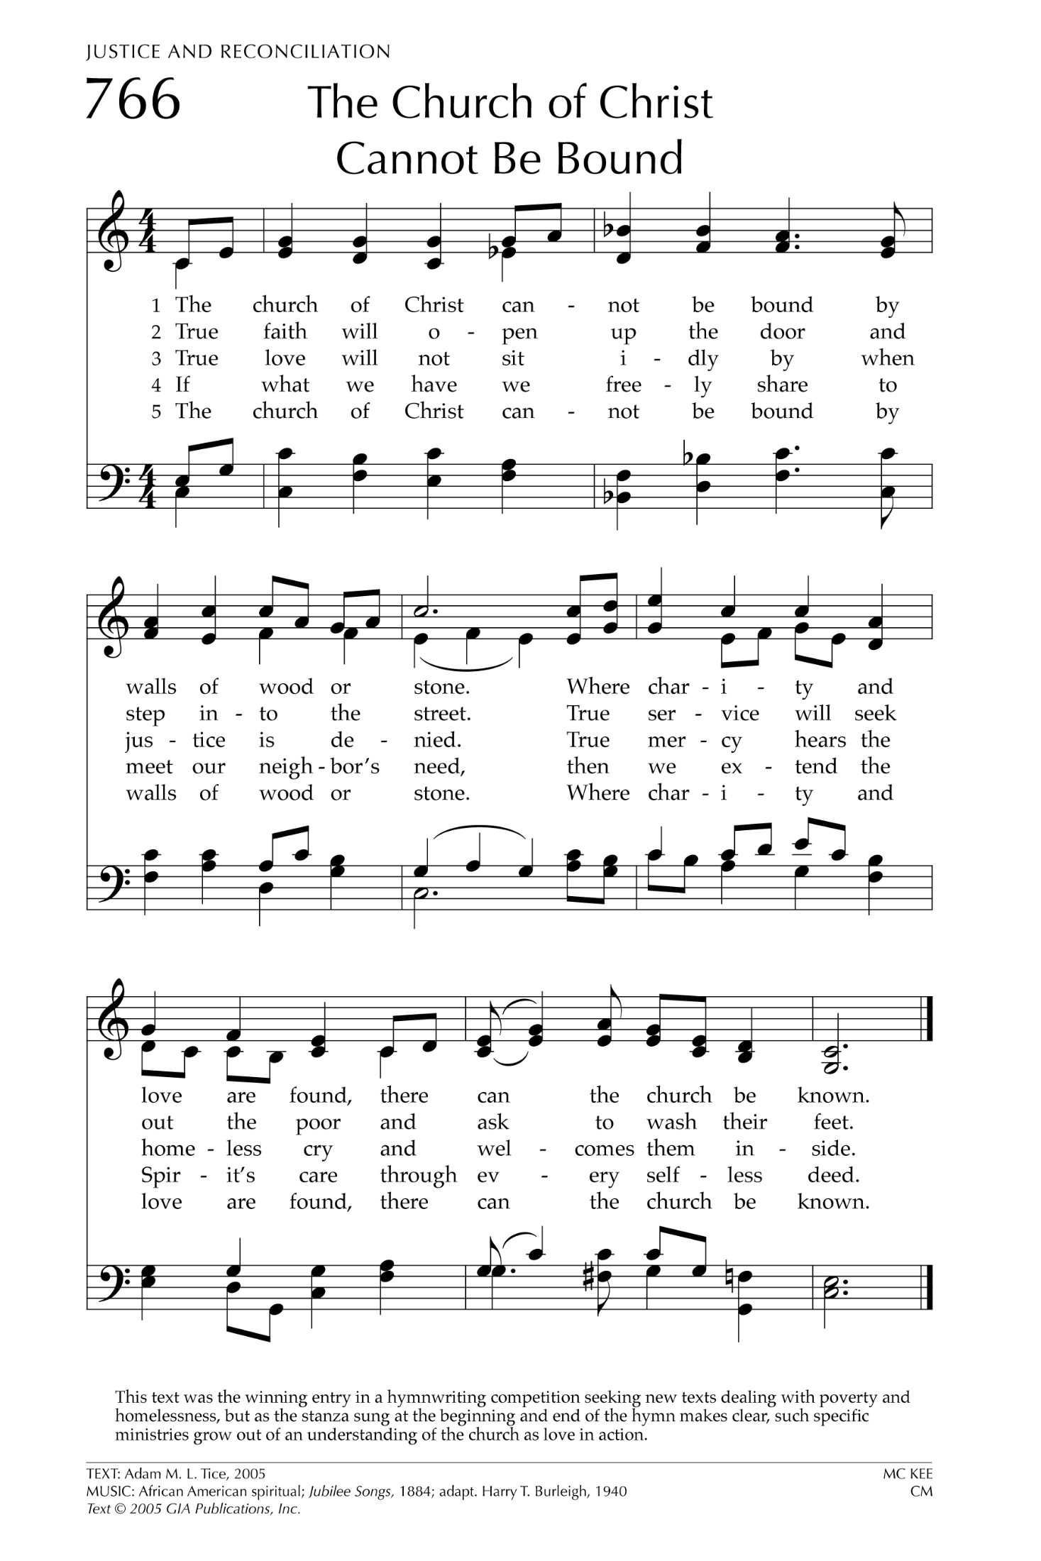
*Prayer of Confession/Assurance of Pardon

We are a people born of water and the Spirit. John 3:5
We have made promises to be Christ’s faithful disciples,
and to show his love to our life’s end.
Although we fail to fulfill those baptismal vows,
God’s faithful love endures forever.
Confident of God’s grace,
let us confess our sin and the sin of this world.

*Unison Prayer
Merciful God,
we confess that we have sinned against you
in thought, word, and deed,
by what we have done,
and by what we have left undone.
We have not loved you
with our whole heart and mind and strength.
We have not loved our neighbors as ourselves.
In your mercy, forgive what we have been,
help us amend what we are,
and direct what we shall be,
that we may delight in your will
and walk in your ways
to the glory of your holy name.

*Assurance of Pardon
Hear the good news! John 3:5; 2 Cor. 5:17
As people born of water and the Spirit
we have died to the old life, and a new life has begun.
God’s grace is poured out upon us day by day.
Come to the water and remember your baptism.
Be thankful,
and live as one who has been raised to new life!
In Jesus Christ, we are forgiven!

Thanks be to God.

*Passing the Peace
During the Passing of the Peace, you are invited to come forward and touch the waters of baptism and remember who and whose you are.

*Hymn #582 “Glory to God, Whose Goodness Shines on Me”

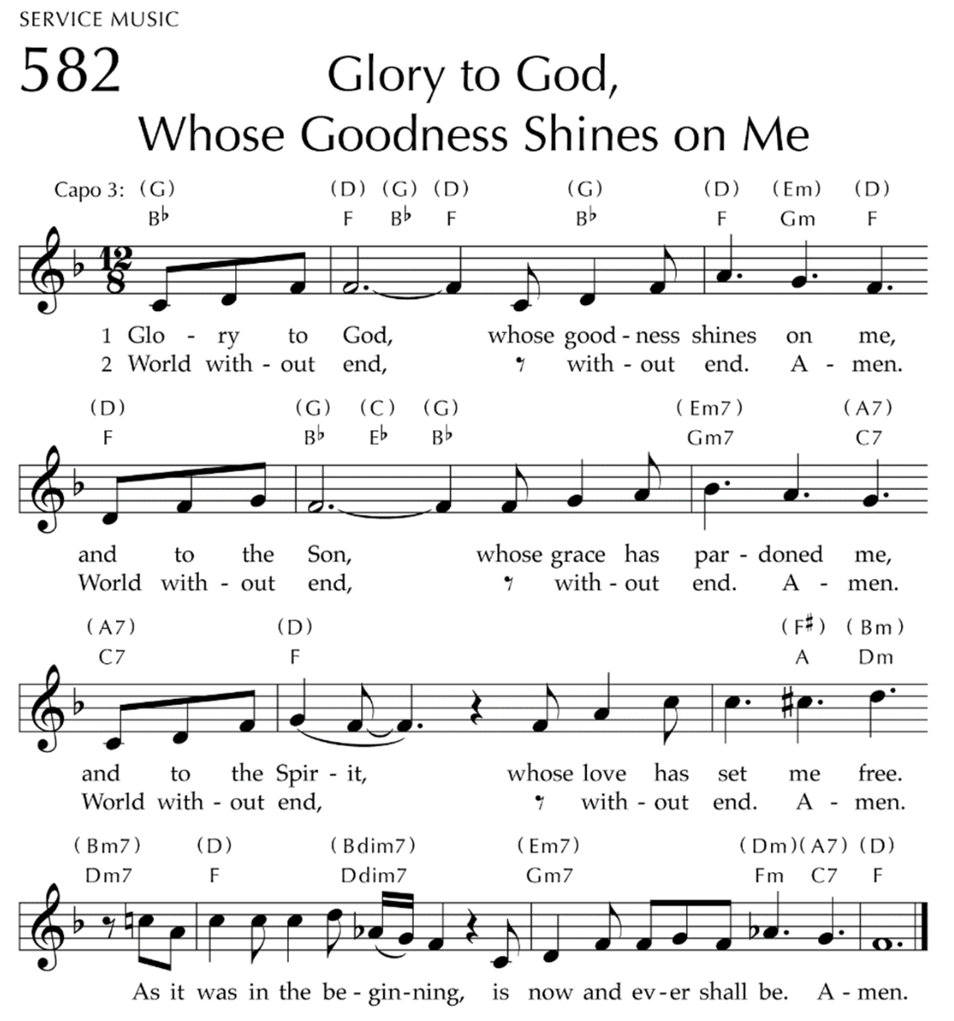

Prayer for Illumination Elder Len Morgan, CLP

Scripture Reading:

Sermon: “Community of Love”

*Hymn #693 “Though I May Speak”

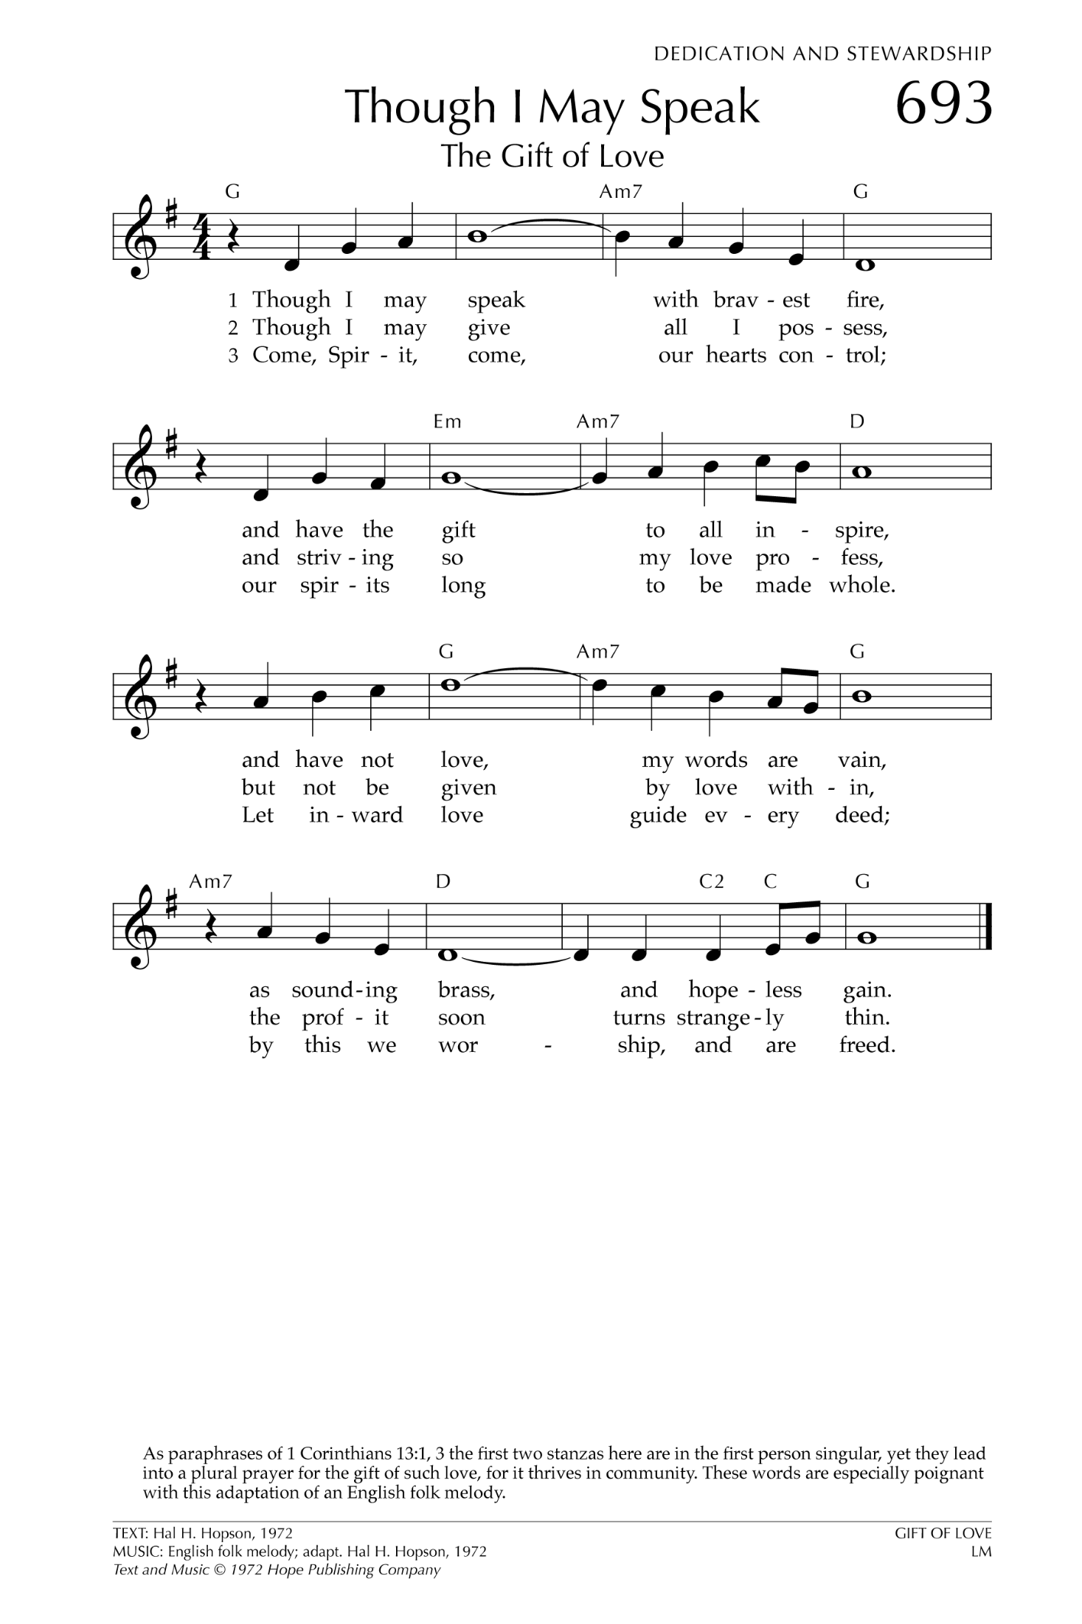

Presbytery Offering offering plates are available by the doors

*Hymn #609 “Praise God, from Whom All Blessings Flow

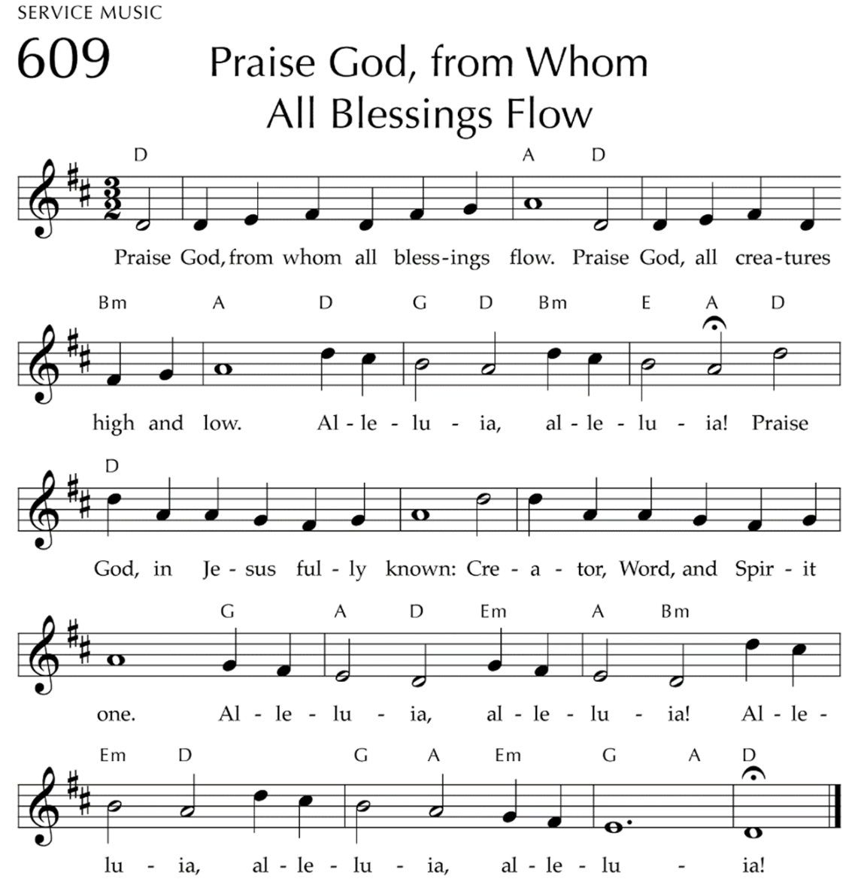

*Prayer of Dedication

Lord’s Supper Rev. Skip Noftzger
Invitation
Great Thanksgiving
Lord’s Prayer
Breaking of the Bread
Sharing of the Bread and Cup

You received your communion elements as you entered the meeting today. Sealed gluten free communion is available.

Prayer after Communion

*Hymn #300 “We Are One in the Spirit”
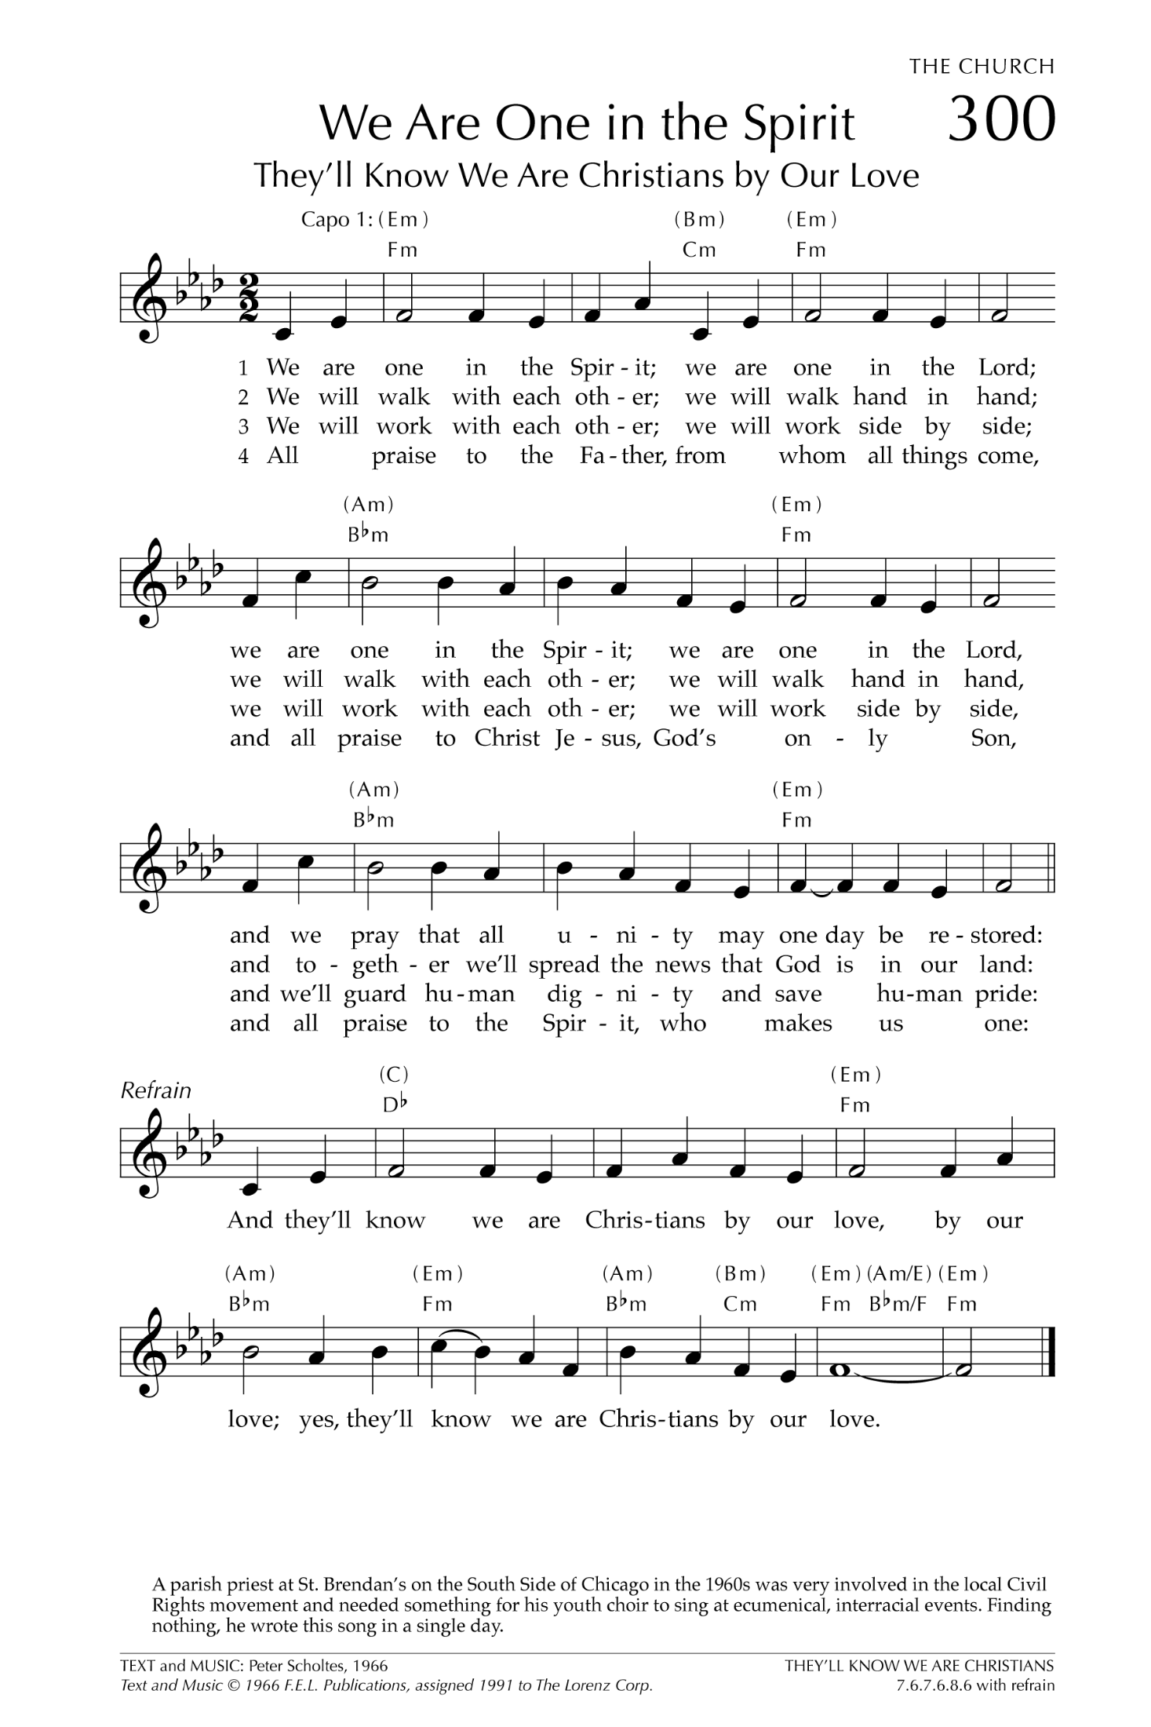

Prayer Teams will be positioned at both sides in the rear during the hymn to pray and anoint with oil anyone who has a prayer concern or thanksgiving.

At the close of the meeting: the Benediction will be offered by Elder Len Morgan

Notes and Copyright Info on Hymns
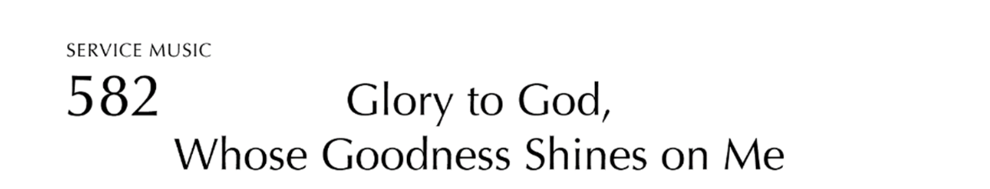
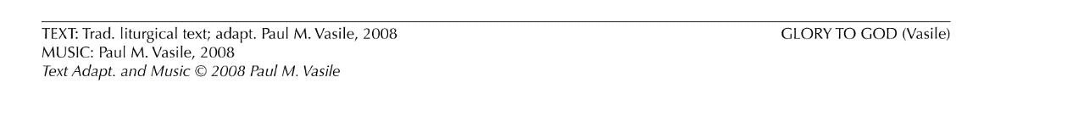

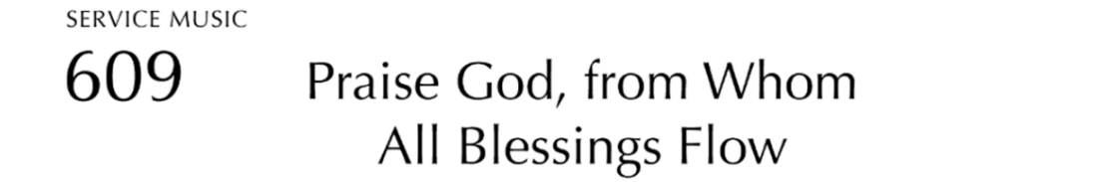
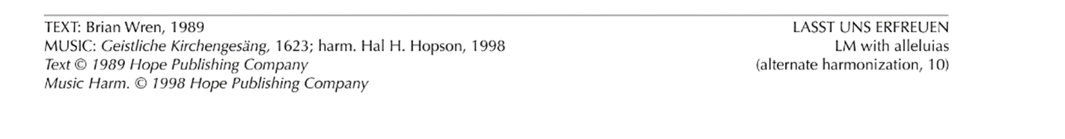

ACTION AGENDA
Nominating Committee

Actions Items

- The Nominating Committee nominates Rev. Owar Ojulu to serve as Vice-Moderator of the Presbytery in 2025
- The Nominating Committee nominates the following people for the standing committees.
Committee on Ministry
Ruling Elder Rick Forsyth; West Hempfield (2027)
Ruling Elder David McMunn; First, Greensburg (2027)

Committee on Preparation for Ministry
Teaching Elder Geoff Rach; Level Green (2027)
Information Items
With the retirement of Executive Presbyter Skip Noftzger, the Nominating Committee will be developing a process next year to solicit ruling elder candidates, particularly. Please keep in mind those who you believe God might be calling to serve the ministries within the presbytery.

Committee on Preparation for Ministry

Action Items

- Inter-Presbytery Leadership Formation Program Report.
Information Items
October 1, 2024, Meeting

- Opening Prayer by Robin Jennings

- Approval of minutes of August 2024 MSP
- Skip reported John Manon has accepted a new call at Blairsville (part of Kiski Presbytery), and will end his time at West Newton in October. John’s name had been on the Nominating Committee’s slate of CPM members for the 2027 term.
- Robin and John are scheduled to read Ordination Exams the week of Oct. 7.
- Updates on Candidates and IPLF Participants

Candidate James Vlosich
Hyiwoit shared that James did not complete the Polity exam offered in September. Although well prepared for the exam, James did not realize the time limitation and left the test mid-way, believing he could return at a later time. There will be opportunity for him to retake in January along with other ordination exams. James is still finalizing a second field ed experience for 2025. Skip shared that James is looking for an opportunity that has a more robust adult and youth ministry to see how it is different from his past experiences as he discerns his call. Committee will meet with James in January.

IPLF authorized preacher – Jackie Eckenrod
Jackie is wrapping up the final elements of her practicums and getting signoffs on completed
items. She has met with Skip about these last details, and is open to new opportunities for
preaching/serving. The Committee voted to move Jackie forward to Committee on Ministry
to discern her Commissioned service if the way be clear.

- Committee will not meet in November and December as we have been in conversation with all those under our care. Skip will provide a year-at-a-glance outline for our use in 2025.

Presbytery Council
[Links to complete copies of the Minutes of Council can be found online at www.redstone.org under the
“Presbytery Council Meeting Dates” tab.]

Presentation and Action Items

- The Council recommends the approval of the 2025 budget presented both in the September and November meetings. (See Appendix “C”)
- The Council will present the Book of Order amendment---G-3.0302d- on removing requirement for overture concurrences
- Communications Network
- Interim Executive Presbyter Search Committee
- Pine Springs Camp report
- Mission network report—congregational missions

Information Items

October 22, 2024, Meeting
Call to Order
Rev. Dawn Sherwood called the meeting to order at 6:32 p.m. for the scheduled meeting and a quorum of members was established.

Approval of Agenda
Rev. Dawn Sherwood identified the agenda that had been distributed through the meeting folder in Dropbox. The agenda for the meeting was approved by consent.

Devotions and Prayer
Rev. Sherwood solicited requests for prayer from the gathered members of Council. Individual members of many of the congregations and communities represented in the room were shared. A few colleagues in ministry encountering heath concerns were noted. Members were reminded of the need to continue to pray for those affected by the hurricanes. After receiving these prayer requests, the entire Council engaged in a time of intercessory prayer lifting up all of those who had been mentioned. .

Approval of Minutes
The minutes for the August 27, 2024 were reviewed as submitted. The minutes were MSP approved as submitted.
Reports
Moderator Report
No report from the Moderator.

Executive Presbyter Report
Executive Presbyter Noftzger reported on a number of events and activities going on within the Presbytery including updates on a couple transitions in pastoral leadership. He noted that many of the areas of shared ministry and mission would be included in the extensive number of reports from the various subcommittees, networks and task forces.

Rev. Noftzger also reviewed some of the specific transitional steps that he has initiated since the last meeting. Some of these included the following items to prepare for next year.
- Established regular meeting schedules for 2025 with Staff Support and Finance subcommittees. Mission and Communications will continue their current patterns.
Producing a planning and production calendar for each subcommittee based upon past practices and concerns

- Met with Associate Clerk regarding Stated Clerk roles and responsibilities. Reviewed all online reporting for both data and OGA records (Eminister, CLC, Church Change Forms, etc.)
- Provided Associate Clerk with an annual planning and production calendar both for OGA reporting and for presbytery cycles.
- Review all necessary hard copy and digital files to ensure they are up to date by the end of the year.
- Currently working alongside Administrative Operations Coordinator on annual production schedule.
- Set up new computer for next EP with default user name/password for ongoing relevant online resources (Dropbox, Email, Constant Contact, In-C, CLC, etc.) Creating master file with all relevant websites, usernames and passwords.

Stated Clerk Report
- The Correspondence Log was included within the meeting documents folder.
- Rev. Noftzger confirmed that the following item of business had been approved by consent since the last meeting.
  - Approval of the recommendation of the Finance and Property committee to authorize removal of the barn at Pine Springs Camp with the funds obtained for the wood to be utilized for restoration/landscaping the site and remaining funds in the Capital Improvement Fund.
- The schedule for the upcoming Council meeting dates (available in person at the Presbytery Center or by Zoom) included the following dates:
  - November 26
- Rev. Noftzger submitted proposed Council meeting dates for 2025 based upon the current rhythm and annual calendar of the past couple of years. Those dates included:
  - January 14
  - February 25
  - April 22
  - June 24
  - August 26
  - October 28
  - December 2
It was MSP to approve the dates as proposed.
- Council members were reminded of the approved dates for the 2025 Presbytery gatherings.
Presbytery 2025
    - January 25---First Presbyterian, Greensburg-approved
    - March 25---McClellandtown-approved
    - May 27—Puckety, Lower Burrell--requested
    - September 23—West Hempfield, Irwin--requested
    - November 22—Newlonsburg, Murrysville-approved
Having received requests from the Puckety and West Hempfield sessions to host the Presbytery meetings in May and September, respectively, it was MSP to approve their requests with gratitude for their offer of hospitality.

- The BOO Amendments task force reviewed their recommendations concerning possible referrals and scheduling of votes assigned to particular presbytery meetings. After noting the necessity for committees to review and make any recommendations prior to the meeting, the proposed schedule and referrals was MSP as submitted.
Upon approving the schedule, Rev. Foster moved and it was seconded by Rev. Blank that three of the four items being brought by the Council to the November meeting be placed on the consent agenda. These included the Episcopal agreement, the presbytery size and the inclusion of adults with vulnerabilities amendments. The remaining amendment concerning concurrence would remain on the action agenda. After discussion, the motion was approved.

Treasurer Report
John Dickson had provided a Treasurer’s report based upon both August and the September, 2024 Income/Expense Report and Balance sheet. All documents were including in the meeting documents folder. He noted the ongoing shortfall in First Fruits contributions for both of those months, contributing to a current deficit despite normal or even reduced expenditures..
Executive Director of Pine Springs Camp
A written report was received from Greg Davis, Executive Director. The report emphasized the ongoing ministry with the successful retreats including both youth groups and individual campers. The “Friends” dinner will be held on Sunday, October 27 and virtually all tables are filled.

The receipt and filing the reports of the Executive Presbyter, Stated Clerk, Treasurer, and Executive Director of PSC was approved by consent.

Interim Executive Presbyter Search Team
Rev. Murphy reported on behalf of the Interim Executive Presbyter Search Team on their progress. She identified that the MDP is posted on the CLC system and they have received two self-referrals along with some “matches.” She noted that the committee has met regularly including that day. Along with Synod Executive Forrest Claassen, they developed a series of interview questions that they plan on using with potential candidates.
Executive Director Greg Davis inquired about the communication of important roles of the EP regarding Pine Springs Camp. The EP serves as an “ex-officio” member of the Pine Springs Board. Given that there may not be an IEP in early 2025, he inquired about possible designation of a “proxy.” It was MSP to designate Rev. Laura Blank as the Redstone Presbytery EP proxy during any time period in which the EP had not begun employment.

SubCommittees/Networks/Task Forces
Finance and Property
A written report was included in the meeting documents. It was recorded that the second reading and presentation of the 2025 budget would take place at the November Presbytery meeting.
In conjunction with Rev. Noftzger, the Finance committee established a 2025 schedule of meetings along with responsibilities based upon the calendar.

Staff Support
A written report was included in the packet. Jack Batthenhouse reported that the committee has assigned a couple representatives to interview any potential Tech coordinator candidates in order to make a recommendation. The committee also established a meeting schedule for 2025.
Worship
Rev. Blank reported on plans for worship for the November Presbytery meeting. The focus will be upon a “Community of Love.” Having focused this year on community and last year on the “Great Ends,” she solicited from the members any suggestions for a theme connecting the worship of the Presbytery in 2025.

Mission Network
A written report was submitted. Rev. Ojulu remarked about the successful mission fair and quilt project from the September meeting. He thanked everyone for their participation. He also spoke of the importance of the presence of Rev. Thomas Tut and the Sudan/South Sudan Partnership Network meeting that was held. The largest constituency for that gathering was from Redstone Presbytery. The offering for the November Presbytery will continue to be dedicated toward the partnership and needs of the South Sudan Presbyterian Evangelical Church.

Racial Justice and Reconciliation
A written report was submitted. The prayer group gathering has continued and my go on after the election. Additional reports and suggestions were made about various prayer vigils taking place on or around election day.
Communications
A written report was included in the packet. A request was submitted by the network to add and link a Presbytery of Redstone Instagram account in connection with the Facebook and YouTube channel. This request was MSP. Additionally, the Communications team requested time on the November Presbytery agenda in order to manage expectations regarding technological capacity for future meetings. Their request was approved by consent. The Presbytery agenda was modified to reflect that action.

Healing Prayer Ministry
On behalf of the Healing Prayer Ministry network, Rev. Murphy announced a two-hour workshop entitled “Praying Jesus’ Way” on 11/9 at the Presbytery center.

November Presbytery Agenda
With the proposed Presbytery agenda in the meeting documents folder, revisions were made based upon the earlier actions. These included moving the three amendments to the consent agenda, replacement of the Racial Justice and Reconciliation time with the Communications network and the addition of a report from the Interim Executive Presbyter search committee. With those revisions, it was MSP to approve the agenda as amended.

Rev. Noftzger was excused from the meeting as the Council conducted its remaining business.
Unfinished Business
There was no unfinished business

New Business
There was no new business.
Adjournment
It was MSP to adjourn the meeting. The meeting was closed with prayer.

 Pine Springs Camp Report to Council-OCTOTBER 2024

I John 3:1-Behold what manner of love the father has lavished on us that we should be called the children of God.

PSC Retreat Highlights

• FUSION for 4th, 5th and 6th Graders- 50 youth and several youth leaders to part in this two day and one overnight camp.

• Women in the Woods- A beautiful weekend greeted 78 women who had an opportunity to hear God’s word, rest in His creation and some even chose to fly through the air on our Zip Line.

• The Big One is this weekend (October 18-20) and we are expecting 100 youth and youth leaders for the weekend.

Please continue to pray for the retreat programs that we run for our campers, any churches that desire to send people, and other youth groups. Our retreats continue to be a blessing to our ministry as we week to provide year-round opportunities for our campers to have vital encounters with Jesus Christ that lead to growth in Christian faith and discipleship.

Fundraising Event Updates

2024 SPORTING CLAY FUNDRAISER
The Annual Sporting Clay Event was held on Tuesday, October 1. It was our 6th annual outing, and we hosted 74 participants, the most we have had. In addition, we were blessed to raise over $10,000 the general operating budget of Pine Springs Camp.

2024 FRIEND’S DINNER
The Annual Friends Dinner is Sunday, October 27 at The Core Event Center in Irwin. Currently we have over 200 people registered for this celebration. We are very thankful for the continued support of churches and individuals who support this event.

Something New-Our first Seminar Series for Parents and Youth Leaders
We are excited to announce, to our Camp Family first, a new event we are hosting. Our Seminar Series will focus on topics that will help parents and others navigate the challenges of today’s culture with the desire to help our children and youth grow in their faith.

Our first Seminar is Saturday, November 9th at First Presbyterian Church of Irwin. The seminar topic “Faithful Parenting in Today’s Culture” will be led by Ed Sutter, a Mental Health Counselor at Waynesburg University and long-time youth worker.

It is our desire for youth to have a “vital encounter with Jesus Christ” and we hope these seminars will provide encouragement and support to parents and those who work with youth. Please see the flyer for details and registration information.

Please pass this along to all you think may be interested!

Mission Network

October 10, 2024, Meeting

Items discussed include:

Collection: Next Presbytery Meeting Offering will go to Sudan / South Sudan.

Rev. Dawn Sherwood joined the meeting and requested information regarding resources to assist Pakistan in evangelizing people interested in becoming Christians. Baptisms are being arranged and Festivals planned. Donna and Skip provided potential websites and names of individuals who may be able to direct her in obtaining resources.

Mission Fair- churches provided displays of their mission activities and27 quilt squares have been submitted. Discussion was better during lunch.

Mission Partnership Network - meeting was well attended. A range of topics were presented, both local and in Sudan. It was evident that helpers and co-workers were affected by the battles as well as the native peoples. A comment was made that the map was helpful.

North Carolina Hurricane -discussion regarding the best way to help the victims concluded that money could be donated to PDA or individual churches may transport items needed to known sites receiving them.

Minutes for Mission – November Presbytery Meeting – Donna to contact folks at Avonmore, Poke Run, Murrysville, or Puckety.
Tabled till next meeting:
2025 Mission Projects and PDA Mission Trips.

Next Meeting – November 14 2024.

Committee on Ministry
Presentation and Action Items

- The Committee on Ministry presents Jackie Eckenrod for commissioning in pastoral service for Districts 2 and 3.
- The Committee on Ministry recommends the designation of Rev. Mary Kay Glunt as Retired status.
- The Committee on Ministry recommends the designation of Rev. Skip Noftzger as Retired status.
Information Items

November 7, 2024, Meeting

Approval of Minutes
MSP to approve the October 3, 2024 minutes.

Report of the Stated Clerk
The Stated Clerk updated the committee on the following items:
- Correspondence Log (Meeting Documents).
- Minutes Review
  - Following churches will be listed as not having their Minutes reviewed.
Adah, Palmer-Glunt | Dunbar-Smith | Merritstown-Smith
Hopewell-McDermott | Ligonier | Calvin, Scottdale-Hart
 |  | Tent-Hart

- Boundary Training session offered November 9 in Greensburg/Zoom. This is a requirement for pastors (MWS/CP) every three years (Ethics and Boundaries Policy-23.11.23).

Report of the Moderator
- MSP the appointment of Rev. Chuck MacPherson to moderate the West Newton United Presbyterian Church until transitional pastoral leadership is approved.

REPORTS OF SUBCOMMITTEES

Examinations and Membership
- Information Items – Conversations around some suggested protocols for examination and ratifications. Information to read about the examination protocols going forward. Being proactive to some potential changes in the BOO.
- Action Items
- MP to approve Jackie Eckenrod for service as a Commissioned Pastor for Districts 2 and 3 on a temporary basis.
Search and Call
- Information Items
- Transition Chart (in the packet/ Dropbox): Irwin continues to look at candidates; Third has started to look for a Covenant pastor; West Newton is looking at candidates for a transitional position.
- Action Items
- MP to recommend to the Presbytery based on her honorable service the change of status of Rev. Mary Kay Glunt from Active to Retired.
- MP to recommend to the Presbytery the change of status of Rev. Skip Noftzger in recognition of his honorable service from Active to Retired effective January 1, 2025.
- MP to approve Patrick Ewing permission to apply to the Session of Third Presbyterian Church, Uniontown.
COM Liaison Responsibilities and Suggested Timeline
- IPLF Recruitment
  - Recruiting new students — Ruling elders interested in spiritual growth, preaching or pastoral leadership.
Care of Congregations and Congregational Leaders
- Prayers were lifted in answer to requests that had been received for:
Praises for churches doing well with new members classes and members joining, baptisms, and confirmation classes planned for January. Praises for churches supporting various missions and projects through fundraisers such as spaghetti dinners. Praises for children regularly attending Sunday School, Children Ministry where kids build with Legos once a month, and bible clubs. Praises for blood drives, hurricane relief through Samaritan purse and PDA, food pantry missions, and carpentry groups performing work in the community. Praises for those that have less budget, but still have big ministry dreams. Praises for good surprise happenings among settled ministries. Praises for the work of PNCs.
Payers for those developing budgets, determining contracts, and working on strategic planning. Prayers for pastors that have recently experienced medical emergencies. Prayers for those with colon cancer, those recovering from falls, those that had suffered a heart attack, and those facing the challenges of dementia. Prayers for all our sisters and brothers that are faced with health challenges, surgeries, and cancer that we may be supportive of one and another.
- The following Teaching Elders and Commissioned Pastors were prayed for during this time:
Glenn Hart, Donna Havrisko, James Hepler, Donna Hess, Doug Holben, Steve Hospodar, Peter Keith, Clark Kerr, Karen Kifer, Brian Kilbert.
- The following churches were prayed for during this time:
Harmony Presbytery Church, Belle Vernon; Marion Presbyterian Church, Belle Vernon; Rehoboth Presbyterian Church, Belle Vernon; United Presbyterian Church, Bolivar; Calvin Presbyterian Church, Brownsville; Ft. Burd Presbyterian Church, Brownsville; Hopewell Presbyterian Church, Brownsville; Colver Presbyterian Church; Cresson Presbyterian Church; Delmont Presbyterian Church.

New Business
If no time sensitive items come up such as candidates for churches, then the COM will not meet on Thursday, December 5, 2024.

Rev. Skip Noftzger thanked everyone for their work on COM, particularly those rotating off of COM.

Rev. Martin Ankrum volunteered to chair the COM starting in January 2025.

MSP to hold the January COM meeting on January 9, 2025 instead of January 2, 2025.

Adjournment
It was MSP to adjourn the meeting at 7:47 p.m. with prayers offered by Rev. Donna Havrisko.

The next regular meeting of the Committee on Ministry will be held at 6:30 p.m. on Thursday, January 9, 2025.

**************************************************************************************************************
October 3, 2024, Meeting

Approval of Minutes
MSP to approve the September 5, 2024 minutes.

Report of the Stated Clerk
The Stated Clerk updated the committee on the following items:
- Correspondence Log (Meeting Documents).
- Minutes Review Dates
  - Churches still needing Minutes Review
Adah, Palmer-Glunt | Dunbar-Smith | Merritstown-Smith
Bolivar-Farrer | Leisenring-Weightman | Calvin, Scottdale-Hart
Hopewell-McDermott | Ligonier | Tent-Hart

- Boundary Training session offered November 9 in Greensburg/Zoom. This is a requirement for pastors (MWS/CP) every three years (Ethics and Boundaries Policy-23.11.23

- MSP to recommend approval of the dissolution of the pastoral relationship between the West Newton United Presbyterian Church and the Rev. John Manon if the way be clear (congregational meeting this Sunday).

Report of the Moderator
None at this time.

REPORTS OF SUBCOMMITTEES

Examinations and Membership
- Information Items – Beginning conversations around some suggested protocols for examination and ratifications.
- Action Items
- MP to approve Rev. Russ Brown as temporary pastoral relationship with the First Presbyterian Church, Fairchance.

Search and Call
- Information Items
- Transition Chart (in the packet/ Dropbox)

COM Liaison Responsibilities and Suggested Timeline
- IPLF Recruitment
  - Recruiting new students — Ruling elders interested in spiritual growth, preaching or pastoral leadership.

Care of Congregations and Congregational Leaders
- Prayers were lifted in answer to requests that had been received for:
Healing prayers for those who suffer from the confusion and memory loss of Alzheimer and are prone to falling. Prayers for those who fell and are in a coma. Prayers for those declining in health. Prayers for healing of relationships. Prayers for strength when dealing multiple surgeries to resolve problems from a first surgery. Prayers for those who have gone through a miscarriage.
Prayers to resolve miscommunication between programs. Prayers for the feed the flock program and continued youth ministry.
Praise starting a bible club in a different elementary school and prayers for this form of ministry continues to grow. Praise for Spaghetti Dinner, successful craft show, and 45 people in attendance at church. Praise for planning Trunk or Treat events which provide an opportunity for youth to gather.
- The following Teaching Elders and Commissioned Pastors were prayed for during this time:
Cliff Foster, Ken Foust, Jennifer Frayer-Griggs, Eric Gilsan, Donald Glunt, Mary Kay Glunt, Pete Goetschius, Donald Graff, Ed Gray, Molly Hall.
- The following churches were prayed for during this time:
Third Presbyterian Church, Uniontown; Trinity United Presbyterian Church, Uniontown; East Liberty Presbyterian Church, Vanderbilt; Sewickley Presbyterian Church, West Newton; Sewickley United Presbyterian Church, West Newton; United Presbyterian Church, West Newton; Palmer Community Presbyterian Church, Adah; Poke Run Presbyterian Church, Apollo; First Presbyterian Church, Avonmore; First Presbyterian Church, Belle Vernon.

New Business
- 'This Child Here' on October 4 (Friday); 3:00 p.m. The Presbytery of Redstone will host a conversation with Rev. Robert Gamble (Executive Director) and Olya Balaban (Program Manager) of This Child Here.
- Wee Kirk 2024 Small Church Conference October 14 – 16. Workshops that provide Christ-centered opportunities for inspiration, encouragement, and community among leaders of small membership.
- Praying Jesus way. Praying Jesus’ Way Saturday, November 9, 2024 9:30 AM to 11:30 AM Redstone Presbytery Office

Unfinished Business
- Westmont COM Team provided an update on the current progress.

Adjournment
It was MSP to adjourn the meeting at 7:23p.m. with prayers offered by Rev. Chuck MacPherson.

The next regular meeting of the Committee on Ministry will be held at 6:30 p.m. on Thursday, November 7, 2024.

